Project Design Phase-II
Technology Stack (Architecture & Stack)

Date | 28 June 2026
Team ID
Project Name | Strategic Product Placement Analysis
Maximum Marks | 4 Marks

Technical Architecture:
The Deliverable shall include the architectural diagram as below and the information as per the table1 & table 2
Example: Strategic Product Placement Analysis using Machine Learning and Data Analytics
Reference: https://cloud.google.com/architecture
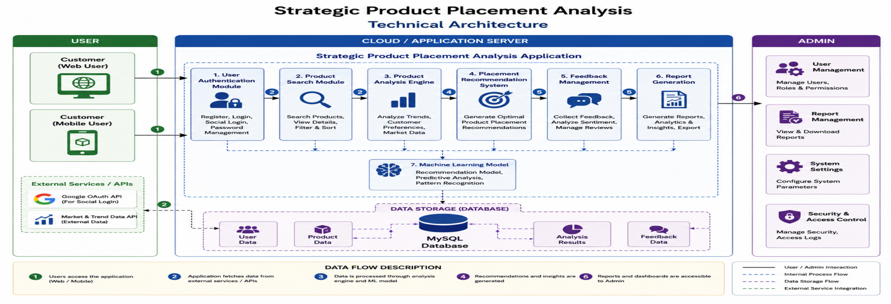
Table-1 : Components & Technologies:
S.No | Component | Description | Technology
1. | User Interface | Web application interface for customers and administrators to interact with the system. | HTML, CSS, JavaScript, React JS
2. | Application Logic-1 | User registration, login, authentication, and user management processes. | Python, Flask
3. | Application Logic-2 | Product search, data analysis, and recommendation processing. | Python, Pandas
4. | Application Logic-3 | Report generation, feedback analysis, and dashboard management. | Scikit-learn, Matplotlib
5. | Database | Stores user information, product data, feedback, and reports. | MySQL
6. | Cloud Database | Cloud-based storage and backup of application data. | Firebase / MySQL Cloud
7. | File Storage | Stores generated reports, documents, and exported files. | Local File System, Google Drive
8. | External API-1 | User authentication through social login services. | Google OAuth API
9. | External API-2 | Market and product trend data collection. | REST API
10. | Machine Learning Model | Product placement prediction and recommendation model. | Scikit-learn

Table-2: Application Characteristics:
S.No | Characteristics | Description | Technology
1. | Open-Source Frameworks | Frameworks used for frontend and backend development. | React JS, Flask, Bootstrap
2. | Security Implementations | Password encryption, authentication, secure access control, and data protection. | SHA-256, HTTPS, Authentication
3. | Scalable Architecture | Three-tier architecture supports increasing users and data. | Three-Tier Architecture
4. | Availability | System remains available through cloud hosting and data backup. | Cloud Hosting, Backup Services
5. | Performance | Fast response using optimized database queries and efficient processing. | MySQL Indexing, Caching

References:
https://c4model.com/
https://www.ibm.com/cloud/architecture
https://aws.amazon.com/architecture
https://medium.com/the-internal-startup/how-to-draw-useful-technical-architecture-diagrams-2d20c9fda90d
https://flask.palletsprojects.com/
https://cloud.google.com/architecture

